CMOS, Digital Electronics, DC response
Q1.
Scenario 1:
A classroom has three temperature sensors to control the temperature of the room by controlling the air conditioner installed in that room. The temperature sensors produce a high output if the temperature crosses a certain threshold. The air conditioner turns on if the outputs of all three sensors are high, otherwise it remains off.
Scenario 2:
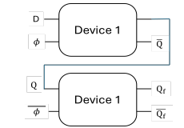

Figure: 1 Figure: 2
Figure 2 shows the output waveshape of the device implemented in Figure 1.
(a) | Identify the logic circuit required to implement the system mentioned in scenario 1 and implement the circuit using 2:1 mux. | [5]
(b) | Identify the circuit implemented in Figure 1 from the timing diagram of Figure 2. Also identify Device 1 shown in Figure 1. | [3]
(c) | Draw the circuit of Device 1 using transmission gates. | [3]
(d) | Explain why n-MOS pass transistors produce good 0 and bad 1, and p-MOS pass transistors produce bad 0 and good 1 with proper mathematical justification. | [4]

Q2.

